Name Surname:Furkan Özer Date:19/12/2025
Number:2023555067 Report No:07
Digital Design Lab Report
Homework / Lab
- Description: Design an 8-bit synchronous Parity Check circuit using VHDL codes. Design in FOR-LOOP and WHILE-LOOP.

- Truth Table of Design
Count of 1’s in i_data | Output
Even | 0
Odd | 1

- Drawing the circuit of desired desing



- Steps of Lab/Homework:
library IEEE;  use IEEE.std_logic_1164.all;  use IEEE.numeric_std.all;  entity parity_check is  port(  i_clk : in std_logic;  i_data : in std_logic_vector(7 downto 0);  o_parity : out std_logic);  end parity_check;  architecture rtl of parity_check is  signal r_data : std_logic_vector(7 downto  0);  begin  p_parity_check : process (i_clk)  variable vparity : std_logic;  variable v_index : integer;  begin  if rising_edge(i_clk) then  r_data <= i_data;  vparity := '0';  v_index := 0;  while v_index < r_data'length loop  vparity := vparity xor r_data(v_index);  v_index := v_index + 1;  end loop;  o_parity <= vparity;  end if;  end process p_parity_check;  end rtl; | library IEEE;  use IEEE.std_logic_1164.all;  use IEEE.numeric_std.all;  entity parity_check is  port(  i_clk : in std_logic;  i_data : in std_logic_vector(7 downto 0);  o_parity : out std_logic);  end parity_check;  architecture rtl of parity_check is  signal r_data : std_logic_vector(7 downto 0);  begin  p_parity_check : process (i_clk)  variable vparity : std_logic;  begin  if rising_edge(i_clk) then  r_data <= i_data;  vparity := '0';  l_parity : for k in 0 to r_data'length-1 loop  vparity := vparity xor r_data(k);  end loop l_parity;  o_parity <= vparity;  end if;  end process p_parity_check;  end rtl;

- Simulation Results:
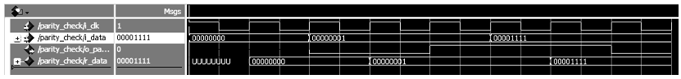

- Conclusion: The proposed module functions synchronously with the clock signal. The input data (i_data) is stored using an internal signal named r_data. Within the process, a for/while loop scans through the bits of the registered data to compute the XOR result (parity). Simulation outcomes verify that the o_parity output accurately reflects whether the number of logic ‘1’s in the stored data is odd (’1’) or even (’0’).

